Project Report



on

***“MITRA Placement Portal”***

***Bachelor of Engineering***

***Electronics & Telecommunication Engineering***

***Sant Gadge Baba Amravati University, Amravati.***

Submitted by

**Name of Students**



Guided by

**Dr. Prof. N.N. Khalsa**

**DEPARTMENT OF ELECTRONICS & TELECOMMUNICATION ENGINEERING,**

**Prof. RAM MEGHE INSTITUTE OF TECHNOLOGY & RESEARCH,**

**BADNERA-Amravati**

2024-2025

**CERTIFICATE**



This is to certify that the project report entitled

***“MITRA Placement Portal”***

has been successfully completed by

**Name of students**

in satisfactory manner as a partial fulfilment of

Degree of Bachelor of Engineering in

(Electronics & Telecommunication Engineering)

Sant Gadge baba Amravati University, Amravati

during the academic year 2024-2025



|  |  |
| --- | --- |
| **Dr. Prof. N.N. Khalsa** | **Dr. S. V. Pattalwar** |
| Guide  Department of EXTC Engineering. PRM Institute of Technology & Research, Badnera | Head,  Department of EXTC Engineering. PRM Institute of Technology & Research, Badnera |

**External Examiner**



**ACKNOWLEDGEMENT**

*It is my moral duty & responsibility to be loyal & grateful to those who have shown me the path by throwing their knowledged rays during the Project.*

*It is worth mentioning here that as a guide* ***Dr. Prof. N. N. Khalsa*** *has encouraged me time to time during the Project. He/she all the while was my co-rider. He/she is the reinforcement of my dissertation. Let me be honest to pay him/her utmost regards for his guidance to which my project proved to be a successful one.*

*Words are insufficient to show my thankfulness to HOD* ***Dr. S. V. Pattalwar*** *who at every point showed me the telescopic way in respect of my project.*

*I am grateful to all the* ***authors*** *of books & papers which have been referred for this Project. Last but not the least, I am thankful to* ***all teaching, non-teaching staff and everyone*** *who directly or indirectly helped me for the completion**of this project.*

**Name of Student**

**CONTENTS**

**CHAPTER 1: INTRODCUTION**

**CHAPTER 2: LITERATURE SURVEY**

2.1 Overview and all theory related to project

**CHAPTER 3: METHODOLOGY**

3.1 System Block Diagram

3.2 Description

3.3 Flow charts

**CHAPTER 4: IMPLEMENTATION**

4.1 working of project

4.2 Actual pictures

**CHAPTER 5: COMPONENT DESCRIPTION**

**CHAPTER 6: APPLICATION**

**CHAPTER 7: ADVANTAGES AND DISADVANTAGE**

**CHAPTER 8: CONCLUSION AND FUTURE SCOPE**

**REFERENCE**

**APPENDIX: PROGRAM**

**CHAPTER 1**

**INTRODUCTION**

The MITRA Placement Portal is developed to bridge the gap between students and recruiters, offering a structured and user-friendly platform for efficient placement management. It digitizes the traditional placement process, minimizing paperwork and maximizing efficiency. The system is designed to handle a large volume of student applications while providing recruiters with easy access to potential candidates. The process of job recruitment and student placement is a crucial element of educational institutions and corporate hiring. However, traditional placement processes involve manual coordination, paperwork, and repetitive tasks, leading to inefficiencies, delays, and a lack of transparency. The MITRA Placement Portal is designed to eliminate these challenges by offering a robust, centralized, and automated solution. The MITRA Placement Portal serves as a bridge between students seeking job opportunities and recruiters looking for qualified candidates. It provides an intuitive and seamless platform where students can manage their job applications, view upcoming placement drives, and receive real-time notifications regarding their application status. Recruiters, on the other hand, can efficiently post job vacancies, screen applicants based on various filters, and schedule interviews without administrative overhead. Given the increasing demand for digital transformation in the hiring industry, the MITRA Placement Portal leverages advanced web technologies and frameworks to deliver a scalable, secure, and user-friendly placement management system.

The system is built using Django and Flask for backend operations, ensuring a structured and modular development approach. The frontend, designed using HTML, CSS, JavaScript, and Bootstrap, ensures an interactive and responsive user experience. MySQL serves as the database backbone, storing critical placement-related information securely and efficiently. The MITRA Placement Portal is a comprehensive web-based application designed to streamline and enhance the campus placement process. Built using a robust technology stack, the portal leverages HTML, CSS, and JavaScript for an intuitive and responsive frontend, while the backend is powered by Python, SQL, Flask, and Django to ensure secure and efficient data handling. This platform facilitates seamless interaction between students, recruiters, and placement coordinators by providing functionalities such as profile management, job postings, applications, and interview scheduling. With an emphasis on user experience and data security, MITRA Placement Portal optimizes the recruitment process, making it more transparent and efficient for all stakeholders. The process of job recruitment and student placement plays a vital role in the transition from academia to the professional world. Many universities and institutions struggle with outdated manual processes, leading to inefficiencies, communication gaps, and difficulties in managing vast amounts of data. The MITRA Placement Portal is designed to address these challenges by offering an intelligent, digital, and streamlined placement management system.

The modern job market is dynamic, requiring students to be proactive in their job search while companies seek the best talent efficiently. The MITRA Placement Portal acts as a bridge between students and recruiters, providing an end-to-end solution for applying, managing, and tracking job applications. This system aims to digitize placement processes, reduce dependency on physical documentation, and introduce a seamless experience for all users. This project leverages cutting-edge web technologies and backend frameworks to deliver a secure, scalable, and high-performance platform.

**CHAPTER 2**

**LITERATURE SURVEY**

The campus placement process plays a crucial role in bridging the gap between students and potential employers. Traditional placement systems often rely on manual processes, making them time-consuming, inefficient, and prone to errors. Various studies and existing placement management systems have attempted to address these challenges through digital solutions.

**1. Existing Systems and Challenges**

Several placement management systems have been developed to streamline the recruitment process, including university-based portals and third-party platforms. However, many of these systems face the following limitations:

1. Complex navigation: Many existing portals have non-intuitive user interfaces, making it difficult for students and recruiters to interact seamlessly.
2. Scalability issues: Some platforms struggle to handle a large number of users simultaneously, causing delays and performance bottlenecks.

**2. Technologies Used in Placement Portals**

To overcome these challenges, various technologies have been explored:

1. Frontend Technologies (HTML, CSS, JavaScript): Ensure a user-friendly and responsive interface.
2. Backend Technologies (Python, Flask, Django, SQL): Provide secure database management, API development, and efficient request handling.

**3. MITRA Placement Portal: A Novel Approach**

The MITRA Placement Portal is designed to address the shortcomings of existing systems by integrating a dynamic frontend with a robust backend architecture. Key advantages of this approach include:

1. Improved User Experience: A well-structured UI using HTML, CSS, and JavaScript enhances accessibility.
2. Efficient Backend Processing: Python with Flask and Django ensures seamless handling of user data and requests.
3. Secure and Scalable Database Management: SQL databases enable structured data storage and quick retrieval.
4. Automation of Placement Activities: Features like automated notifications, job filtering, and real-time status updates streamline the recruitment process.

**CHAPTER 3**

**METHODOLOGY**

**3.1 Proposed Methodology**

The development follows an Agile methodology, ensuring continuous improvements through iterative development cycles. The process is divided into the following phases:

A. Requirement Analysis

1. Identify stakeholders (students, recruiters, placement officers).
2. Gather functional and non-functional requirements.

B. System Design

**Frontend (Client-Side):**

1. Uses HTML, CSS, JavaScript for an interactive UI.
2. Implements responsive design for mobile compatibility.

**Backend (Server-Side):**

Developed using Python with Flask and Django for handling user authentication, job postings, and database management.

**Database Management:**

* Uses SQL to store user profiles, job details, and application records.
* Security & Authentication:
* Implements JWT-based authentication for secure login.
* Ensures role-based access control for students, recruiters, and admin users.

C. Implementation

* Develop frontend components such as login forms, dashboards, and job listings.
* Build backend APIs for handling user authentication, job posting, and application tracking.
* Integrate database operations using SQL to ensure efficient data management.
* Implement automated email notifications for job updates and interview schedules.

D. Testing & Debugging

* Perform unit testing for each module.
* Conduct integration testing to check the interaction between frontend, backend, and database.
* Use user acceptance testing (UAT) to validate functionalities with real users.

E. Deployment & Maintenance

* Deploy the application on cloud servers (AWS/GCP) or a local server.
* Monitor performance and security vulnerabilities.
* Regularly update features and fix bugs based on user feedback.

**3.2 Structure of the Project**

The MITRA Placement Portal follows a modular structure, ensuring scalability and maintainability:

1. **ADMIN MODULE**

* Login
* Job Post
* Applicant for Job
* Sort by the Filter
* Search by Name, Branch
* Logout

1. **USER MODULE**

* Registration
* Login
* View Job Post/ Apply
* Sort by Name, Post
* Edit Profile
* Change Password
* Logout

**3.4 Flow Chart**

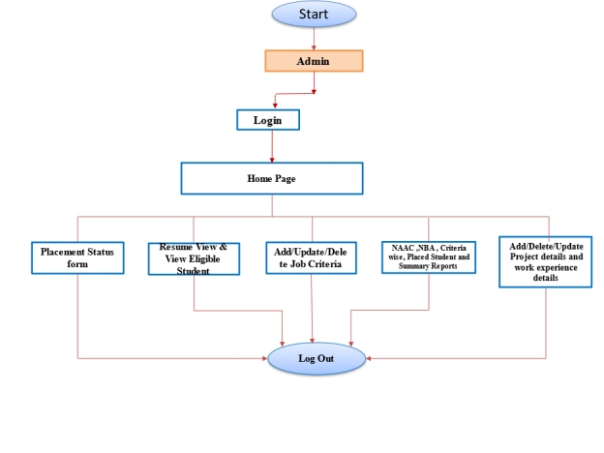

Fig. 3.1 ADMIN MODULE

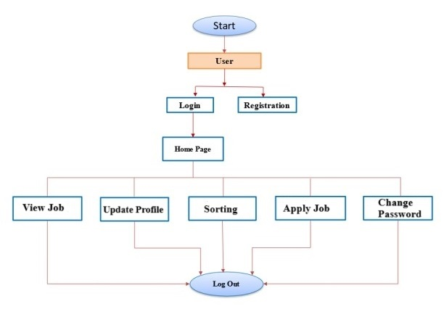

Fig. 3.2 USER MODULE